**PROJECT**

Submitted To:-

Mr. Ankit Verma

Submitted By:-

Name – Aman kr Pandey

Section – BCADS21

Roll Number – 1240258063

**SCHOOL OF COMPUTER APPLICATIONS**

**NO SQL and DBaas 101 (NO SQL)**

**(BCADSN13202)**

**PROJECT**

1. Complex Filters & Projections

**Q1: -** List the names and departments of students who have more than 85% attendance and are s

skilled inboth "MongoDB" and "Python".

**Query: -**

db.students_full.find(

{ attendance: { $gt: 85 }, skills: { $in: ["MongoDB", "Python"] }})

**Output: -**

* Nothing will show up because there aren’t any students who have both ‘MongoDB’ and ‘Python’ skills and more than 85% attendance.
* Use **comparison operators** like $gt (greater than).
* Apply **array matching** with $all to ensure multiple elements exist.
* Use **projection** to show only required fields.
* Build **compound filters** using multiple conditions.

**Q2: -** Show all faculty who are teaching more than 2 courses. Display their names and the total

number of courses they teach.

**Query: -**

db.faculty_full.aggregate(

[{ $project: { name: 1, totalCourses: { $size: "$courses" }}},

{ $match: { totalCourses: { $gt: 2 }}}])

**Output: -**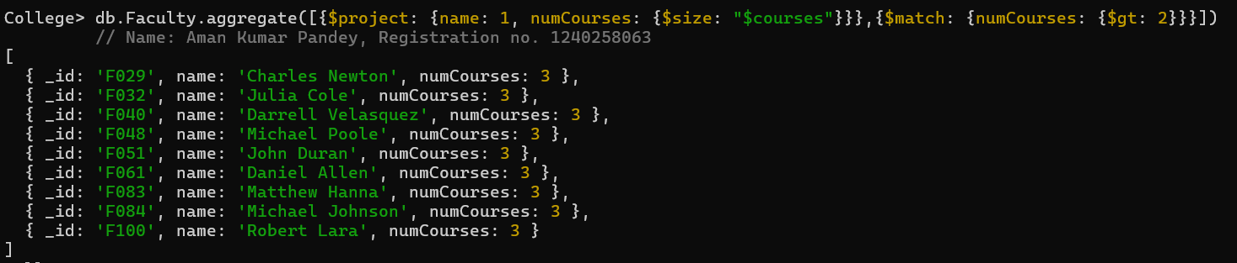

* Use $project to create computed fields.
* Use $size to count array elements.
* Combine $match after projection for conditional filtering.
* Understand aggregation pipelines.

2. Joins ($lookup) and Aggregations

**Q3: -** Write a query to show each student’s name along with the course titles they are enrolled in

(use $lookup between enrollments, students, and courses).

**Query: -**

db.enrollments_full.aggregate(

[{ $lookup: { from: "students_full", localField: "student_id", foreignField: "_id",

as: "student_info" }},

{ $unwind: "$student_info" }, { $lookup: { from: "courses_full", localField: "course_id",

foreignField: "_id", as: "course_info" }},

{ $unwind: "$course_info" }, { $project: { _id: 0, student_name: "$student_info.name",

course_title: "$course_info.title" }}])

**Output:-** 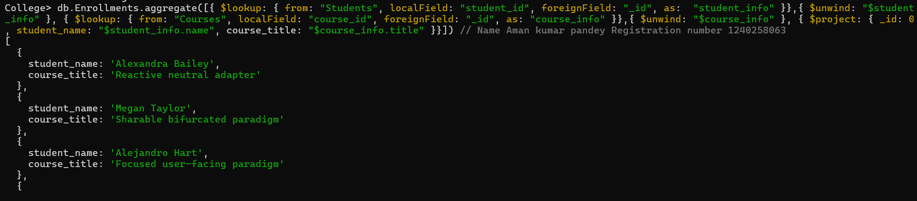

* Use $lookup for joins between collections.
* Combine multiple $lookups for complex relationships.
* Use $arrayElemAt to extract single values from arrays.
* Understand MongoDB’s relational-like linking.

**Q4: -** For each course, display the course title, number of students enrolled, and average marks

(use $group).

**Query: -**

db.enrollments_full.aggregate(

[{ $group: { _id: "$course_id", total_students: { $sum: 1 }, avg_marks: { $avg: "$marks" }}},

{ $lookup: { from: "courses_full", localField: "_id", foreignField: "_id", as: "course_info" }},

{ $unwind: "$course_info" },

{ $project: { _id: 0, course_title: "$course_info.title", total_students: 1, avg_marks: { $round:

["$avg_marks", 2] }}}])

**Output:-** 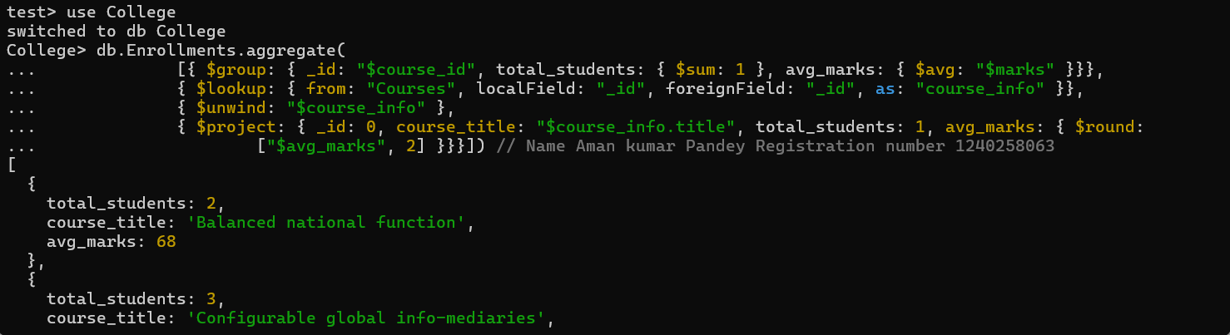

* Use $group for summarizing data.
* Use $avg and $sum to calculate aggregates.
* $unwind helps to deconstruct arrays.
* $project to rename and structure output.

3. Grouping, Sorting, and Limiting

**Q5: -** Find the top 3 students with the highest average marks across all enrolled courses.

**Query: -**

db.enrollments_full.aggregate(

[{ $group: { _id: "$student_id", avg_marks: { $avg: "$marks" } } },

{ $sort: { avg_marks: -1 } },

{ $limit: 3 },

{ $lookup: { from: "students_full", localField: "_id", foreignField: "_id", as: "student_info" }},

{ $unwind: "$student_info" },

{ $project: { _id: 0, student_name: "$student_info.name", avg_marks: { $round: ["$avg_marks", 2]

}}}])

**Output:-**

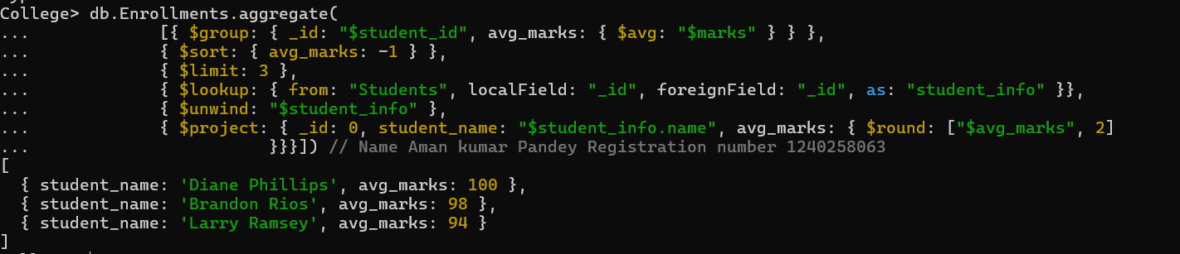

* $sort sorts data in ascending/descending order.
* $limit restricts results to top records.
* $group for calculating averages.
* Combining joins with grouping.

**Q6: -** Count how many students are in each department. Display the department with the highest

number of students.

**Query: -**

db.students_full.aggregate(

[{ $group: { _id: "$department", totalStudents: { $sum: 1 }}},

{ $sort: { totalStudents: -1 }},

{ $limit: 1 },

{ $project: { _id: 0, department: "$_id", totalStudents: 1 }}])

**Output:-** 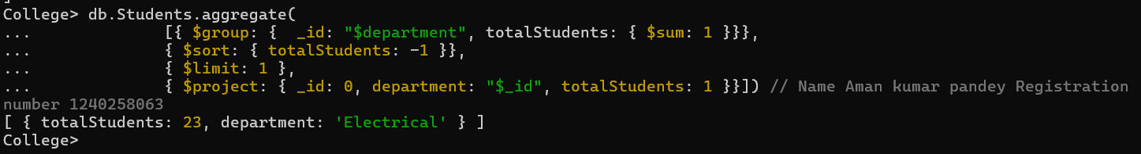

* Count items per category with $sum: 1.
* Use $sort to rank results.
* Identify top-performing or most populated groups.
* Apply $limit to get top results.

4. Update, Upsert, and Delete

**Q7: -** Update attendance to 100% for all students who won any "Hackathon".

**Query: -**

db.students_full.updateMany(

{ activities: "Hackathon" },

{ $set: { attendance: 100 }})

**Output:-**

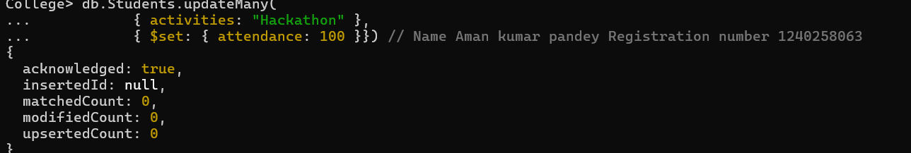

* Use updateMany() for bulk updates.
* $set modifies specific fields.
* Target documents via **nested fields**.
* Understand bulk updates with filters.

**Q8: -** Delete all student activity records where the activity year is before 2022.

**Query: -**

db.activities_full.deleteMany(

{ year: { $lt: 2022 }})

**Output:- **

* Delete records conditionally using deleteMany().
* $lt filters by less than a value.
* Manage dataset cleanup.
* Apply conditional data management.

**Q9: -** Upsert a course record for "Data Structures" with ID "C150" and credits 4—if it doesn’t

exist, insert it; otherwise update its title to "Advanced Data Structures".

**Query: -**

db.courses_full.updateOne(

{ _id: "C150" },

[{ $set: { title: { $cond: [{ $eq: [“$title”, null] }, “Data Structure”, “Advanced Data Structures"]},

credits: { $ifNull: [“$credits”: 4]}}}],

{ upsert: true })

**Output:-** 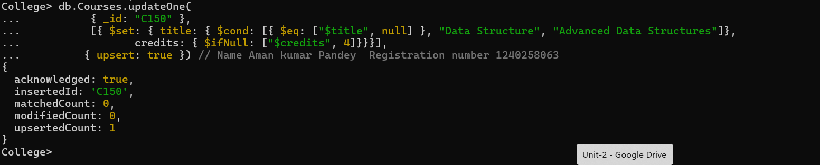

* upsert: true inserts if no match is found.
* $setOnInsert applies only when inserting new data.
* $set updates fields if record exists.
* Handle both **insert and update** in one command.

5. Array & Operator Usage

**Q10: -** Find all students who have "Python" as a skill but not "C++".

**Query: -**

db.students_full.find(

{ $and: [{ skills: "Python" }, { skills: { $ne: "C++" }}]})

**Output:- **

* $in checks for presence in arrays.
* $nin checks for absence in arrays.
* Combine both for exclusive conditions.
* Operate effectively on array fields.

**Q11: -** Return names of students who participated in "Seminar" and "Hackathon" both.

**Query: -**

db.activities_full.aggregate(

[{ $group: { _id: "$student_id", activityTypes: { $addToSet: "$type" }}},

{ $match: { activityTypes: { $all: ["Seminar", "Hackathon"] }}},

{ $lookup: { from: "students_full", localField: "_id", foreignField: "_id", as: "student_info" }},

{ $unwind: "$student_info" },

{ $project: { _id: 0, name: "$student_info.name" }}])

**Output:-** 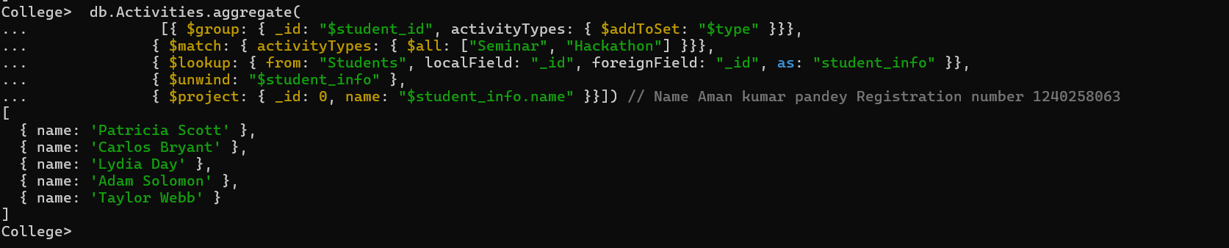

* $all ensures all specified elements exist in an array.
* Simple array querying in MongoDB.
* Combine multiple filters in a single query.
* Efficient participation tracking.

6. Subdocuments and Nested Conditions

**Q12: -** Find students who scored more than 80 in "Web Development" only if they belong to the

"Computer Science" department.

**Query: -**

db.enrollments_full.find(

{ course_title: "Web Development", marks: { $gt: 80 }, department: "Computer Science" })

**Output:- **

* Nothing will show up because there are no students in the Computer Science department who scored more than 80 in 'Web Development'.
* Access nested fields using dot notation.
* Combine multiple field conditions.
* Query subdocuments efficiently.
* Focused filtering by department and performance.

7. Advanced Aggregation (Challenge Level)

**Q13: -** For each faculty member, list the names of all students enrolled in their courses

along with average marks per student per faculty.

**Query: -**

db.faculty_full.aggregate(

[{ $lookup: { from: "courses_full", localField: "courses", foreignField: "_id", as: "courseInfo" }},

{ $unwind: "$courseInfo" },

{ $lookup: { from: "enrollments_full", localField: "courseInfo._id", foreignField: "course_id", as:

"enrolledStudents" }},

{ $unwind: "$enrolledStudents" },

{ $lookup: { from: "students_full", localField: "enrolledStudents.student_id", foreignField: "_id",

as: "studentInfo" }},

{ $project: { _id: 0, facultyName: "$name", studentName: { $arrayElemAt:

["$studentInfo.name",0] }, marks: "$enrolledStudents.marks" }},

{ $group: { _id: { facultyName: "$facultyName", studentName: "$studentName" },

averageMarks: { $avg: "$marks" }}},

{ $project: { _id: 0, facultyName: "$_id.facultyName", studentName: "$_id.studentName",

averageMarks: 1 }},

{ $sort: { facultyName: 1, studentName: 1 }}])

**Output: -** 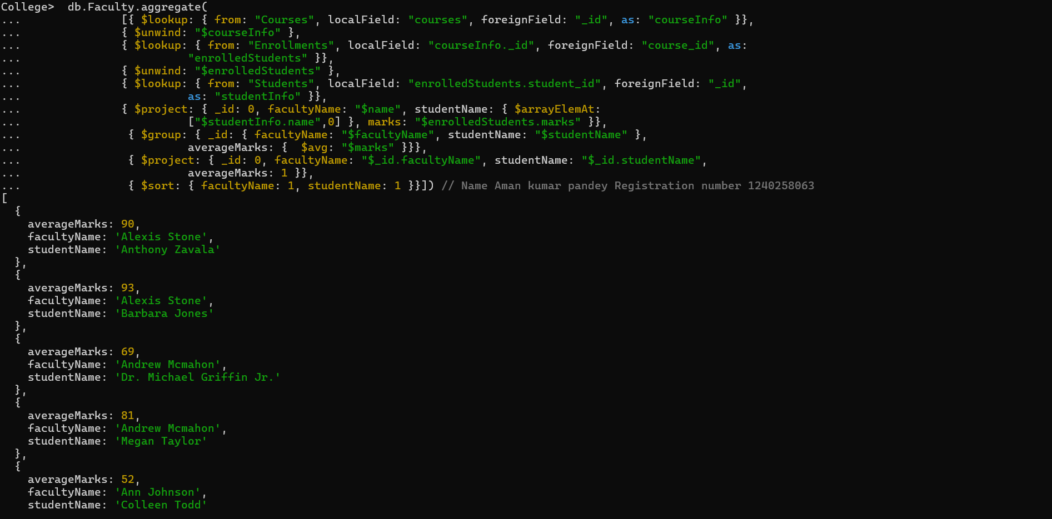

* Multi-level joins using $lookup.
* $addToSet to avoid duplicate student names.
* $avg to compute average marks per faculty.
* Real-world aggregation chaining.

**Q14: -** Show the most popular activity type (e.g., Hackathon, Seminar, etc.) by number of

student participants.

**Query: -**

db.activities_full.aggregate(

[{ $group: { _id: "$type", participants: { $sum: 1 }}},

{ $sort: { participants: -1 } },

{ $limit: 1 }])

**Output: -** 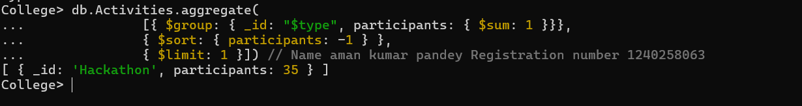

* $unwind to count array elements.
* $group and $sum for totals.
* $sort to rank results.
* Identify “most popular” entities.